NOTE: THIS IS A DRAFT TRANSLATION. IT STILL NEEDS TO BE REVISED

General Presentation
Éveil aux langues
Socrates/Lingua Project 42137 - CP - 1 - 97 - 1 - FR - Lingua- LD

Languages day by day
Level 2: starters…
The didactic material in a wink…

Domain concerned: Word formation (and in second place, etymology)
Levels concerned: Last two years of primary school

Intended aims in the didactic material:

(The same aims as in level 1, especially)
- Observe attentively the elements in non-familiar alphabets, so as to find out what is different or similar between these elements.
- Distinguish between different non-familiar alphabets
- Analyse the procedures of word formation in a non-familiar language and in a non-familiar alphabet. This includes being able to:

- Recognise the repetition of a part of a word in a text written in a non-familiar language and in a non-familiar alphabet.
- Deduce a principle of word formation by composition from the observation of this repetition.

- Establish correspondences between the written form and the sound -for languages that have a non-familiar alphabet- different to those used in the familiar languages.

(Aims for the second level)

- Recognise the existence of resemblances between words of different languages, when listening and when reading;
- Conceive languages and cultures as open worlds that share and exchange their elements.
- Conceive the sharing and the exchanges of elements between languages as related to cultural phenomena (historical or contemporary).
- Know the origin of the names of days in the language/s used in school (first language(s), elementary historical and cultural knowledge)
- Analyse the procedures of word formation in the language used in school.

General Presentation

Session | Activity | Languages concerned | Documents | Interdisciplinarity
Session 1 | Classify written elements in languages (non Latin languages), by locating common parts. Listen to a cassette to locate this parts orally. Put the days in order thanks to authentic calendars. | Chinese, Japanese, Mongolian, Russian. | Written and audio documents | Calculate the Sino-Japanese numbers.
Session 2  (Facultative)* | Discovery of a different system of word formation for the names of days, dealing with numbers. | Persian | Written and audio documents | Plastic arts: calligraphy (Persian)
Session 3 | Discovery (by listening and by reading) the similarities between the names of days in different languages. Awareness of their common Latin origin. | Spanish, Italian, Rumanian | Written and audio documents
Session 4 | Widening to other languages in which the names of days have the same origin. Researches on this common origin (names of planets in Latin and Roman divinities) | Catalan, Spanish, Welsh, Italian, Judaeo-Spanish, Rumanian | Written and audio documents | Solar system, ancient divinities
*As there is a possible danger of weariness. Session 2 may be a bridge with another didactic material, devoted to numeration.
Description of the cassette’s content

Session 1 | Chinese | days of the week
Session 1 | Japanese | idem
Session 1 | Mongolian | idem
Session 1 | Russian | idem
Session 2  (facultative) | Persian | days of the week
Session 2  (facultative) | Persian | numbers from 1 to 5
Session 2  (facultative) | Persian | days of the week
Session 2  (facultative) | Arabic | idem
Session 3 | Spanish, Italian,  Rumanian, language  of Luxembourg,  German, Greek, Russian | “find the odd one” game
Session 3 | Italian | days of the week
Session 3 | Spanish | idem
Session 3 | Rumanian | idem
Session 4 | Italian | days of the week
Session 4 | Spanish | idem
Session 4 | Rumanian | idem
Session 4 | Welsh | idem
Session 4 | Catalan | idem
Session 4 | Judaeo-Spanish | idem
Session 4 | English | idem

N.B. In the recording for session 4, all the weeks start with “Monday” except for the one in Judaeo-Spanish (which starts by “alhad” – Sunday).

Languages, Day by Day

Level 2: starters

SESSION 1
Description of the activity:  This session is based on a corpus of names of days in 4 languages in a non-familiar alphabet.  Pupils will first make a classification on the basis of written words, and then will classify the days from the oral | Proposed languages  Chinese, Japanese, Mongolian, Russian
Main aims:  The pupils are expected to apply the following skills (knowledge and savoir-faire) or attitudes:  - Observe attentively the elements in the non-familiar alphabets, so as to find out what is different or similar between these elements.  - Distinguish between different non-familiar alphabets.  - Recognise the repetition of a part of a word in a text written in a non-familiar language and in a non-familiar alphabet.  - Deduce a principle of word formation by composition, from the observation of this repetition. | Pedagogical organisation:  · Material  - Labels  - Paper 25 * 35  - Felt pens, glue  - Cassette  - Labels organized by the teacher  - Authentic calendars (instead of an authentic Mongolian calendar, which is not provided, they may use the teachers card; most of the times in Chinese calendars there isn't the word “yobi” which means day)  · Group organisation  Homogeneous groups of 3 or 4 pupils. A reporter from each group may be appointed.  ·Length  45 minutes

Session 1

Development of the session

Introduction

-Give out to each pupil the labels with the four series of days as well as a paper 25 * 35, glue and felt pens.
-Ask the pupils if they can guess what it is and what they think they will have to do.
Expected answer: There are alphabets which the pupils have already seen (or: they have never seen– depending on the didactic materials they have used previously); They have already worked with these labels (the previous year); it is about days of the week; they have to be organized in languages (and make sure that there are 7 days for each language), and try to put them in the right order.
-Confirm (or indicate) that although some of the pupils may have already seen these alphabets, they haven’t seen the names of the days of the week in these languages yet.

Research:

Tell the pupils: “You will classify these names of days in languages and then you will have to write down why have you classified it that way”. Give them time enough to stick up the words on the paper and to write down their justifications. (N.B. if some of the groups haven't finished the four series – which is not very probable – help them to reach it before going forward.

Tell the pupils: “You are going to hear a recording in this four languages as many times as necessary in order to verify your classification and so as to put the days of the week in order”. At this stage (if it hasn't been done yet), the names of the four languages should be given in order to facilitate the later dialogue on the languages.

Synthesis – Structure

Tell a pupil to explain and justify the classification and the order of the days done by his/her group taking as a basis what has been written by them. Let the other pupils express their comments.

Expected reactions and propositions:

- Each time there are two languages which use the same kind of alphabets.
- Different references to the knowledge already learnt (depending on the materials used) on these alphabets, hypothesis on the name of the languages.
- The classification in series is possible (thanks to the repetition of parts of words, the Russian list is made of words in Cyrillic where there is no repetition. It is not possible to put the names in order (except for the names in Chinese).
- The languages, which have a more different alphabet to ours (ideograms, Sino-Japanese alphabet…) also have symbols which are repeated in every word. For the Japanese, the one that is repeated is the final part,. For the Chinese it is the first part.
- The part that is repeated in Chinese is the first one, and in Japanese is the last one: These two languages are read from left to right as in English.
- Regarding Chinese, some of the pupils (especially if they have seen the Chinese numbers in class) may make hypothesis that the end of the word is a number.
- One of the languages which has a more similar alphabet to ours (Cyrillic alphabet) has a part that is repeated in each name of day at the end. In that case, it is read from left to right, as in French. But what they will hear is really different to what they thought it was written (it is not “rapar” as they thought)

If the pupils make a hypothesis regarding the presence of numbers in the Chinese names, make them count the strokes and make them put the days in order.

Propose to the pupils to use an authentic document (calendars) so as to put the names of the days in order (If there is not enough time, they can put in order only one language with Sino-Japanese alphabet and a language with Cyrillic alphabet.

Extensions:

-Cultural discovery of the country (food, clothes…) especially for Mongolian
-Look for other languages with similar alphabets.

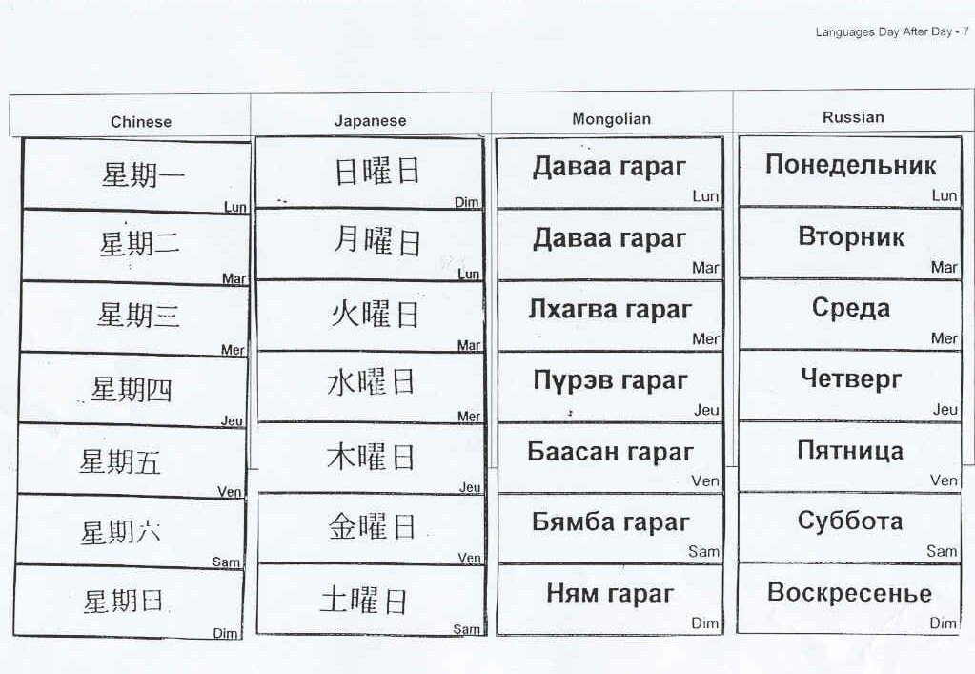

Depending on the languages it can be a loan phenomenon (In Welsh, the names of days are loanwords from Latin) or languages with common roots (Italian, Rumanian, French… are the product of evolutions from Latin). This distinction has not been made in this didactic material. If other materials have introduced it previously, the teacher may reinforce it at the time of this session. Otherwise, the teacher may talk globally on the origin of the names of days

